 | 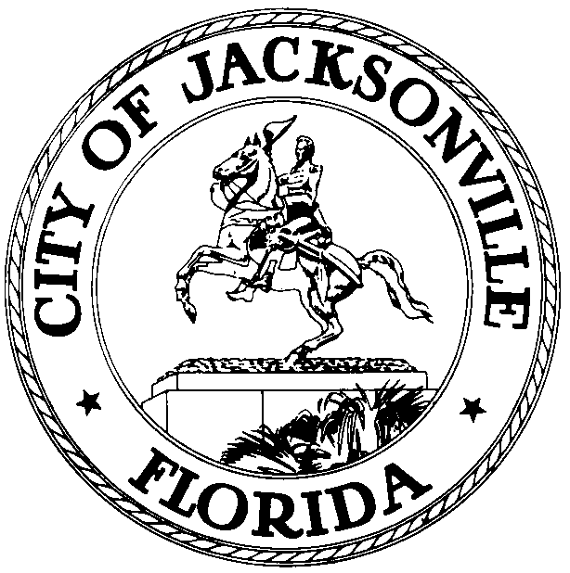
 | OFFICE OF THE CITY COUNCIL
CLAY YARBOROUGH
PRESIDENT |  | SUITE 425, CITY HALL
COUNCIL MEMBER, DISTRICT 1 |  | 117 WEST DUVAL STREET
OFFICE (904) 630-1389 |  | JACKSONVILLE, FLORIDA 32202
FAX (904) 630-2906 |  | E-MAIL: CLAY@COJ.NET

January 6, 2015

A M E N D E D M E M O R A N D UM

TO: Members of Council

FROM: Clay Yarborough, Council President

RE: Special Committee on CIP
____________________________________________________________________________

In accordance with Council Rule 2.103(a), as President of the Jacksonville City Council, I hereby continue the Special Committee on CIP to March 31, 2015.

CHARGE: Review all City Capital Improvement Projects (CIP) and take a detailed look at their current status, allocations, future appropriations, and debt service. Make recommendations to the Finance Committee and Council regarding closure of various projects and appropriate transfers as a result thereof.

MEMBERS: Lori Boyer – Chair
Matt Schellenberg
Bill Gulliford
Greg Anderson
John Crescimbeni

DEADLINE: The Special Committee is tasked to report its findings with recommendations by April 30, 2015.

I appreciate the willingness of the members to devote the necessary attention to this important issue.

CY/bp

cc: Council Members/Staff
Cheryl Brown, Director/Council Secretary
Jeff Clements, Chief, Research Division
Dana Farris, Chief, legislative Services Division
Rachel Welsh, Information Systems Administrators
Kirk Sherman, Council Auditor
Media Box

